8th Grade Junior High Music

**JAZZ UNIT**

**What is Jazz?**

I. **Jazz is America’s Music**

A. Jazz was born in the ______United ______ ______States_____.

1. Jazz was born out of the ____African ______ _____American______ experience in America.

Combining _____African_____ & ___European_______ musical traditions.

2. Jazz evolved from ____work songs_______, _____spirituals_____________,

__blues_______, ____brass band music_____, and ___ragtime_____.

3. Jazz first appeared in the city of ___New Orleans______ in the early__1900s___.

4. ____African______ ___Americans________ created the major elements of jazz and were

the ones who led the changes for many decades.

B. Jazz is American music, because it is a perfect example of ____democracy_________.

1. Individual ____freedom_____ but with responsibility to the ___group____.

II. **Improvisation**

A. _____Improvisation_________ is the key element of jazz.

1. Outside of music, it is __inventing____ something on the spur of the moment to

a certain __situation___.

2. In music, it is when ___musicans_____ perform a different

___interpretation_____ each time they ___play_____ the same tune.

3. An example of improvisation in everyday life is regular conversation. Jazz musicians do the

same with their __instruments______. It is a ___musical _____

___conversation______.

Show the Jazz Improvisation/Conversation analogy sheet from Lesson Plan 2, Section II (p. 2/2 of teacher packet)

B. Jazz is like a _____languge__________.

1. Language communicates _____thoughts________ and ____ideas_______.

2. Language cannot express ___emotions____ like music.

3. Jazz musicians, through ___improvisation_______, create “____emotion_____ of

the ___moment______”.

4. Jazz is different than __classicl______ ___music ___ in how it is written.

Classical music: _written down ahead of time & played the way the composer wrote it_

Jazz: _most of the music is “spontaneously composed” – depends on how the musicians feel at that given moment_

Requires the listener__to be alert at all times_.

A piece of jazz music is __never____ __played____ the same way twice.

C. In jazz, it is more about the _way__ a song (tune) is played instead of __what__ tune is played.

1. Jazz musicians can create new _elements__ and _moods__ to any song.

2. Jazz musicians have their own, unique way of __playing__ _their__ _instruments_.

3. You must __listen__ a lot to jazz to hear the difference. The more you listen, the more

you can recognize a particular player by his/her _playing_.

**Jazz Recordings**

Found on web site under Lesson Plan, Section III

1.*Chameleon* – Herbie Hancock 2. *The Entertainer* – John Arpin

3. *How High the Moon* – Ella Fitzgerald 4. *Lonely Woman* –Ornette Colman

5. *Take Five* – The Dave Brubeck Quarter 6. *Main Stem* – Duke Ellington

**Basic Jazz Musical Elements**

1. Note – a single _pitch__ of _music__

2. Melody – a group of _notes__ played in _succession_

3. Chord – two or more different _notes_ produced at the same time

Chords produce _harmony_.

Chords create _emotion__.

Jazz chords are made up of _3__ to _6_ notes.

Chords played in succession are called a _chord__ _progression_.

Play the explanation from web site under Lesson Plan 2, Section I (p. 3/3 in teacher packet.

4. Accompaniment – the _background_ music

5. Improvisation – playing something that is not _written_ ahead of time.

6. Syncopation – accenting or _emnphasizing_ the _weak_ beat – the _”upbeats”__ beat.

(When your foot is in the air when you are tapping the beat.)

Syncopation = _natural_ for jazz musicians/No syncopation = _boring_

7. Instruments

a. _saxophone_ e. _bass_

b . _trumpet_ f. _guitar_

c. _trombone_ g. _drums_

d. _piano_ h. _voice_

Use notes from teacher packet under Lesson Plan 2, Section IV (p. 2/2) to talk about the sound of different players and to play examples of different people playing the same instrument.

8. Tempo – the _speed_ of the _music_

Slow = _ballad_ Fast = _”burning”_

9. Swing

2 meanings:

* When everyone in the band is in _sync_.
* Way of playing _eighth_ _notes_: _long_-_short_, lilting feel

Play audio snippets of non-swinging and swinging tunes in Lesson Plan 2, Section V (p. 3/3) in teacher packet.

This is the way most jazz is played.

Big bands in the 1930s and early 1940s period played in the style called _Swing_ _Era_.

Play audio snippets of Swing Era in Lesson Plan 2, Section V (p. 3/3) in teacher packet.

10. Form

a. Every jazz tune is built on a set of predetermined _chord_ _changes_ that accompanies the

_melody_. The chord changes are in a _sequence_ such as _AAB_, _AABA_, _ABAC_, etc.

b. Playing through the chord changes 1 time is called the _chorus_.

c. Playing a jazz tune is playing through the _chorus_ many times – one right after the other.

d. The first time the tune (melody) is played it is called the _head_.

e. The next time the _chorus_ is played, a jazz musician improvises a _solo_ over

the chord changes. The _solo_ can last for more than one _chorus_.

The _solo_ is finished when the player _nods_ to the next soloist.

The _audience_ usually _applauds_ at the end of each solo.

f. When the last soloist _finished_, the band plays the _head__ again – making it the end

of the tune.

g. An _introduction_ is often before the first chorus and after the last chorus there is an

_ending_.

h. The form of a jazz tune is like a sandwich:

C:\Users\Michelle\AppData\Local\Microsoft\Windows\Temporary Internet Files\Content.IE5\68J1AHR2\MC900013328[1].wmf INTRODUCTION

ENDING

i. Who does what is called an _arrangement_. Arrangements can be _predetermined_ ahead of

time by talking through how the piece will be played or they are _written_ _out_. This is

usually the case for _bigger_ _bands__.

Play and show the form for “Song for My Father” under Lesson Plan 2, Section V (p. 4/4).

**Each Instrument’s Responsibility**

**I. Horns**

1. Saxophone, trumpet, & trombone are responsible for playing written or improvised _melodies_.

**II. Rhythm Section**

1. Job is to _accompany_ & _provide_ _support_ for the horn players. (Can play solos as well.)
2. The following instruments make up the rhythm section:
3. _Piano_

Main job is to play _chords_. This is called _comping_ NOT “accompany”.

Play the Comping and Syncopation audio snippet from teacher packet of Lesson Plan 3, Section I (p. 2/3)

1. _Bass_

Main job is to play the _roots_ of the chords and “_lay_ _down_ the _groove_”.

It is the _”glue”_ that holds everyone together.

1. _Drums_

Main job is to keep the _beat_ _steady_.

Lays down the _groove_ with the bassist.

Play the Rhythm Section Roles audio snippet from teacher packet of Lesson Plan 3, Section I (p. 2/3).

**III. Guitar**

1. Double duty: like a horn player playing _melody_ or like a _pianist_ comping chords.

**Where Did Jazz Come From?**

**I. New Orleans via Africa and Europe**

A. Jazz is a combination of _African_ and _European_ music.

1. African music, jazz got its:

a. _rhythm_ and _”feel”_

b. _”blues”_ quality

c. _expressing_ of oneself

2. European music (_classical_ _music_), jazz got its:

a. _Harmony_

b. _Instruments_

3. African & European

a. _Improvising_

**II. Why New Orleans?**

A. It is a _port_ city.

B. It is _meeting_ _place_.

1. It is a _nightlife_ city.

**III. African American Experience**

A. Jazz came out of _slave_ _songs_and spirituals (_religious_ African

American folk songs)

B. Jazz’s originators and most important innovators were primarily _African_ _American_.

C. Louis Armstrong

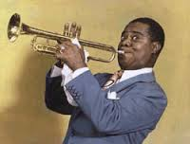 1. Most important jazz _originator_ and first truly great jazz _soloist_.

2. Played _trumpet_ and _sang_.

**Ragtime**

**I. Piano Style**

A. Ragtime is primarily a _solo_ _piano_ _style_ and was the _precursor_ to jazz.

1. It started in the late _1800s_ and early _1900s_.

2. Each hand of the piano player does something _different_:

a. _Left_ hand plays a _steady__, almost _march_-_like_

of alternating _bass_ notes and chords creating “_oom_-_pah_”.

b. _Right_ hand plays _syncopated_ melodies in a “_”ragged”_” fashion.

3. Ragtime is primarily an _African_ _Americna_ invention and was a source

of pride to African American _composers_,

_musicians_, and _listeners_.

4. Ragtime’s inventor and most important pianist and composer was _Scott Joplin_.

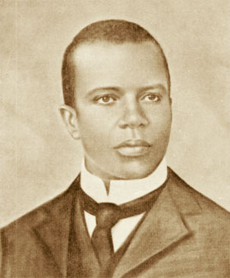

5. _Records_ were not invented when ragtime started. Instead, it was recorded on

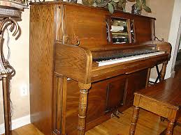 _player_ _piano_.

6. Pieces of ragtime music is called _rags_.

7. Ragtime really isn’t jazz, because it rarely uses _improvisation_.

Jazz did come from this music as bands tried to imitate the _ragtime_ _style_.

_Improvisation_ was added and, thus, _jazz_ was born.

Play “The Entertainer” from teacher packet Lesson 4, Section II (p. 2/4).

**II. European and African Traits within Ragtime**

1. European

1. _Piano_ is an European instrument.

2. _Left _ _hand__ (bass line) came from European _classical_ _music_ and

_marches_.

3. The _chord_ _progressions_ were from European classical music.

4. Ragtime uses standard European _musical_ _notation_ .

1. Africa
2. The right hand’s syncopated melodies came from _polyrhythms_ (many different

rhythms played at the _same_ _time_).

**III. Reflects American Attitude in the late 1800s & early 1900s**

1. American Traditions (conservatism, motherhood, rural life) - _piano_

_left hand rhythms_

1. New Traditions - _fasst_- _paced_ _living_ = right-hand syncopation

C. Conservative & Liberal Attitudes

a. Conservative - _performed on the piano_ = _white middle class_

b. Liberal – _ragtime’s syncopation_ = _exciting pace of modern industrial life_

**Dixieland**

**I. The Music**

A. Dixieland developed between _1900_ - _1928_.

B. 4 main influences:

1. _ragtime_

2. _military brass bands_

3. _blues_

4. _gospel music_

C. Instrumentation of Dixieland Band:

_trumpet_ - plays the _melody_ (jazzed up)

_clarinet_ - adds to the melody (_embellishes_)

_trombone_ - embellishes the _bass_ _line_, but sometimes plays

the _melody_; plays _”afterbeats”_ and does _sound_ _effects_ (“smears” and “slides”)

_piano_ and _banjo_ - play _chords_

_string_ _bass_ or _tuba_ - plays the _bass_ _line_

_drums_ - keeps the _beat_ steady and _swinging_

D. General Information

1. Dixieland jazz is “_collective_ _improvisation_”. All of the musicians

_improvise_ at the same time.

2. Originally Dixieland bands were small _marching_ _bands_.

3. Dixieland bands played for _dances_, _parties_ and in the early 1900s they also

played for _funerals_ to celebrate the life of the one departed.

4. Most famous Dixieland musician is _Louis Armstrong_.

a. Considered the first great jazz _soloist_ (improviser) and one of the most

important _figures_ in jazz _history_. Without him there would be no jazz!

b. He played long _solos_.

5. Almost all Dixieland jazz musicians were _African_ _American_. However,

the first jazz recording was made by an all _white_ group known as the

_Original_ _Dixieland_ _Jass_ _Band_.

Play the video of Louis Armstrong:

<http://www.youtube.com/watch?v=wyLjbMBpGDA>

E. Cultural Implications

1. The collective _improvisation_ of Dixieland jazz represented, in part, African

American’s new found _freedom_.

2. Early jazz made it way from New Orleans, to _Chicago_, to _New York, to the _rest of the

country_.

2. Dixieland was the musical backdrop of city life during the _Roaring_

_Twenties_ (AKA the Jazz Age) and the early years of _Harlem_

_Renaissance_.

**Swing Era**

**I. Music**

A. Big band swing developed and grew from _1930_ - _1945_.

1. The Swing Era is also known as the _Big_ _Band_ _Era_ since there were

a larger number of _instruments_ used in the bands of this era compared to the

_Dixieland_ era.

2. An ensemble with 10 or more instruments is called a _Big_ _Band_.

*Baritone Sax*

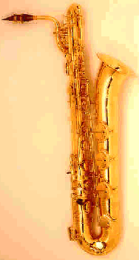 3. The most common number of instruments in a big band is _17_.

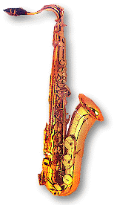

_5_ saxophones (2 alto, 2 tenor, 1 baritone saxophone)

*Tenor Sax*

_4_ trumpets

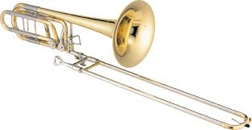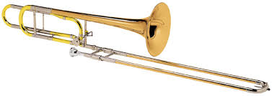 _4_ trombones

*Tenor Trombone*

*Bass Trombone*

_4_ rhythm: piano, bass, drums, guitar

4. Most of the music is written/arranged by an _arranger_.

a. The music of the swing era is more _complex_ than in the _Dixieland_

_Era_.

b. A lot more _organization_ is required ahead of time than in Dixieland. Room

has to be made for _improvisation_ and the solos are much _shorter_.

5. The swing music is primarily for _dancing_. Swing bands were called

_dance_ _bands_.

6. _Call_ and _Response_ was a common form.

a. The first phrase is called the _call_. It is played by one _section_.

b. The second phrase is called the _response_. It is played by a _different_ _section_.

Play <http://www.youtube.com/watch?v=4zk41mOMf9o> for call & response (introduction only)

Count Basie

Duke Ellington

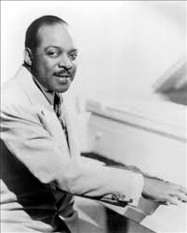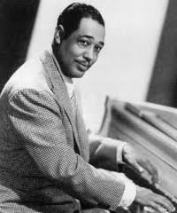

7. The most important figures in the Swing Era were:

a. _Duke Ellington_ - pianist

Benny Goodman

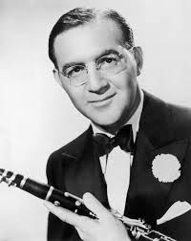

b. _Count Basie_ - pianist

c. _Benny Goodman_ - clarinetist. He was known as the “_King_ of _Swing_”.

8. There were a few _small groups_ as well that dominated the Swing Era.

One was _Benny_ _Goodman_ _Trio_,

_Quartet_, and _Sextet_.

Play audio snippets of swing music from teacher packet Lesson Plan5, Section II (p. 3/4).

**II. Cultural Implications**

A. After the _Stock_ _Market_ _Crash_ of _1929_, swing helped the country

through the _Great_ _Depression_.

B. Jazz reached new levels of sophistication in the Swing Era as an outgrowth of

_America’s_ need for self-esteem following the Great Depression.

C. Swing served as a major _morale_ booster during _World__ _War_ _II_.

D. Race Relations

1. Swing allowed for _racial_ _integration_. It didn’t matter what _color_ you were, just how

well you could _play_.

2. _Benny_ _Goodman_ led the way to interracial groups in _1935_.

(Prior to this date, jazz groups were either all _white_ or all _black_.)

3. _Duke_ _Ellington’s__ music of the early _1930s_ was the musical

backdrop during the later years of the _Harlem_ _Renaissance_.

4. Jazz was (and remains) a symbol of _urban_ _American_ energy, optimism, and

resilience.